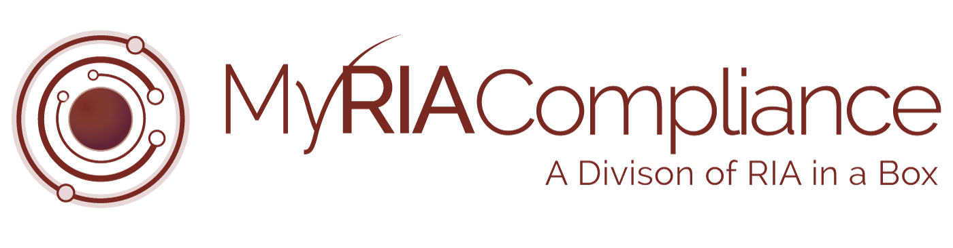

*The following document is provided to You as a sample only.  Prior to using or implementing this document or any portion thereof, You should tailor the contents, including any highlighted sections, to fit your specific situation and should consult relevant regulatory authorities and/or legal counsel. RIA in a Box and its compliance division (“We”) do not represent or warrant that the contents of the document are suitable for You from a compliance, regulatory, legal, or any other perspective. We shall have no responsibility or liability for your use or non-use of the document or any portion thereof. We are not law firms, investment advisory firms, or CPA firms and do not provide legal advice or opinions.* ***Please note that highlighted references should be changed to the actual intended reference.***

Copyright © 2018 RIA in a Box LLC

RIA Firm Name is a registered investment adviser.  Information presented is for educational purposes only and does not intend to make an offer or solicitation for the sale or purchase of any specific securities, investments, or investment strategies.  Investments involve risk and, unless otherwise stated, are not guaranteed.  Be sure to first consult with a qualified financial adviser and/or tax professional before implementing any strategy discussed herein. Past performance is not indicative of future performance.